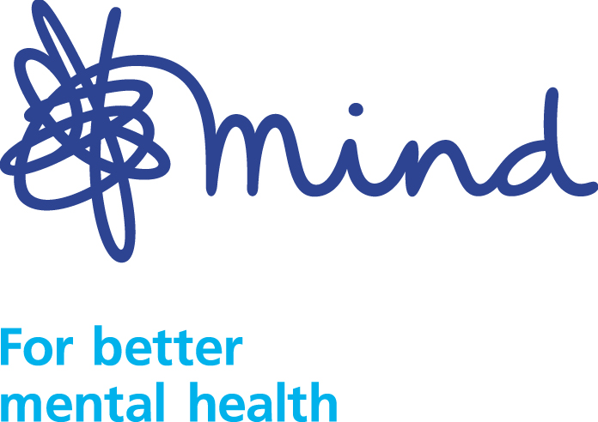
For Office Use Only:
Date Entered
Entered by
Number FIT
ANONYMOUS
Mind in Harrow

Equalities Monitoring Form

This information will be used to ensure we provide services to all sections of the population. Please help us by answering as many questions as you can. Thankyou.

1. Your age

18-20 21-35 36-50 51-65 66+

2. Do you consider yourself to have a disability? (Please read below).
Under The Equality Act 2010, a person is disabled if they have a physical or mental impairment which has a substantial and long-term adverse effect on their ability to carry out normal day-to-day activities, which would include things like using a telephone, reading a book or using public transport.

Yes No

If “Yes” please indicate the type of impairment, which applies to you (by ticking next to it below). People may experience more than one type of impairment in which case tick all types that apply.
Physical mobility |  |  | Learning disability
Blind / partially sighted |  |  | Dyslexia
Deaf / hard hearing |  |  | Autism
Speech / language impairment |  |  | Brain injury
Mental health problems |  |  | Facial disfigurement
Long-term health conditions  (e.g. cancer / HIV / MS) |  |  | Other hidden disability:
Other progressive disability |  |  | Do not wish to disclosure

3. Marital status

Civil Partnership Married Single

4. Pregnancy and maternity
Are you pregnant or currently breastfeeding? Yes No

5. Caring responsibilities
A Carer is defined as someone who provides unpaid care or support to a family member, neighbour, or friend on a regular / substantial basis because of illness, disability or age.

Do you have caring responsibilities? Yes No

6. Your gender Male Female

Is this gender the same as your gender at birth? Yes No

7. Your sexual orientation

Bisexual Gay man Gay woman / Lesbian Heterosexual

Prefer not to say Other, please write in
8. Your faith or belief (please tick appropriate box)
No religion |  |  | Sikh
Christian* |  |  | Jain
Buddhist |  |  | Parsi / Zoroastrian
Hindu |  |  | Baha’I
Jewish |  |  | Other faith group, please write in:
Muslim
* including Church of England, Catholic, Protestant and all other Christian denominations

9. Your ethnic group
These are based on the 2010 Census categories. Please choose ONE ethnic group and tick or write in appropriate box to indicate your ethnic background.

A. ASIAN OR ASIAN BRITISH D. MIXED
Afghani
Bangladeshi
Indian
Pakistani
Sinhalese
Sri Lankan Tamil
Any other Asian background, please write in:

White & African
White & Caribbean
White & Asian
Any other Mixed background, please write in:

B. BLACK OR BLACK BRITISH E. WHITE
Caribbean
Ghanaian
Nigerian
Somali
Any other Black background, please write in:

C. OTHER ETHNIC GROUP
Arab
Chinese
Iranian
Iraqi
Kurdish
Lebanese
Any other ethnic group, please write in:

Albanian
British
Gypsy/Roma Traveller
Irish
Irish Traveller
Polish
Romanian
Serbian
Any other White background, please write in:

10. Please choose one of the categories below which is relevant to you:

Service User-Project ………………… Recruitment–Post.…………..……

Volunteer-Project …………………… Staff Trustee Carer

Date form completed: …………………………...

